

COMPUTATIONAL INTELLIGENCE | MRCET
(CSE – ARTIFICIAL INTELLIGENCE AND MACHINE LEARNING)
Email: mrcetsocse4@mrcet.ac.in
IV Year B. Tech-II Semester Major Project Summary Sheet

Project Title: | HireLens AI – Explainable AI Resume Screening System
Project Code: | R22A6695 |  |  |  | Batch Size: |  | 03 | Batch: |  | 2022-26
Domain/Area: | Natural Language Processing (NLP) and Explainable AI (XAI) |  |  |  | SDG Mapping: |  | Decent Work and Economic Growth
Abstract: | HireLens AI is an Explainable Artificial Intelligence–based resume screening system designed to make recruitment faster, transparent, and more data-driven. Most existing Applicant Tracking Systems (ATS) work as black boxes, providing hiring decisions without any reasoning, which creates confusion for both candidates and recruiters. HireLens AI solves this by using Natural Language Processing (NLP) and machine learning to extract key details like skills, education, work experience, projects, and certifications from resumes, then comparing them against job descriptions to generate a compatibility score along with clear, interpretable explanations of matched skills, missing qualifications, and relevant experience. It also includes a side-by-side candidate comparison feature to help recruiters make better-informed decisions. The expected outcome is an AI-powered recruitment tool that brings efficiency and fairness to the hiring process, helping recruiters choose the right candidates while giving applicants clear insight into their evaluation.
Technical (S/w & H/w) Specifications |  |  |  | Module(s) Specifications
Software Specifications Hardware Specifications  - Frontend: React 19, Vite 8.0, TailwindCSS - Python 3.10+, FastAPI, SQLAlchemy - NLP: spaCy, sentence-transformers, SHAP - DB: SQLite via SQLAlchemy ORM - Processor: Intel i5 (8th gen) or above - Memory: 8GB or above - Hard Disk: 5GB free space (SSD preferred) - Internet Connectivity |  |  |  | Module 1: Resume Upload & Parsing  Module 2: Job Description Submission & Parsing  Module 3: AI Feature Extraction & Scoring Engine  Module 4: Explainability & Report Generation  Module 5: Batch Processing & Candidate Ranking  Module 6: Candidate Comparison & UI/UX Dashboard
Architecture Diagram |  |  |  | Methodology
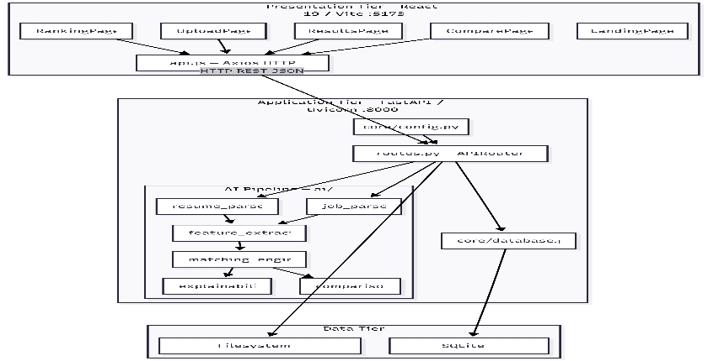 |  |  |  | - Analysis: Identified the lack of transparency in ATS hiring decisions and the need for explainable AI in recruitment.  - Design: Planned a six-stage XAI pipeline with weighted scoring, NLP-based parsing, and a React frontend.  - Development: Built resume parser, job parser, matching engine, explainability module, and React UI with FastAPI backend.  - Testing: Verified match score accuracy, explanation quality, and UI responsiveness across different resume formats.  - Deployment: Deployed locally using Uvicorn and Vite dev server; tested end-to-end with sample resumes and job descriptions.
Existing System |  |  |  | Proposed System
- Commercial ATS platforms (Workday, Greenhouse) operate as black boxes with no explanation for hiring decisions.  - Keyword-based filters cause false rejections for synonymous skill terms.  - No multi-dimensional scoring or candidate comparison in existing tools. |  |  |  | - Explainable AI pipeline with transparent, human-readable justification for every screening decision.  - Weighted multi-dimensional scoring across skills, experience, education, and projects.  - Batch processing, ranked leaderboard, and side-by-side candidate comparison with hiring recommendation.
Guide Details |  |  | Batch Members Details
 |  | Mr. S. Venkateswara Raju  Associate  Professor in Department of CI  MRCET Campus  UGC Autonomous Institution  -Govt. of India Hyderabad |  |  |  |  |  |  | 
 |  |  | Bheemanapally Abhaya Sri |  |  | Bochkar Nikhith |  |  | Jakkireddy Sri Charan Reddy
 |  |  | 22N31A6627 |  |  | 22N31A6629 |  |  | 22N31A6666

